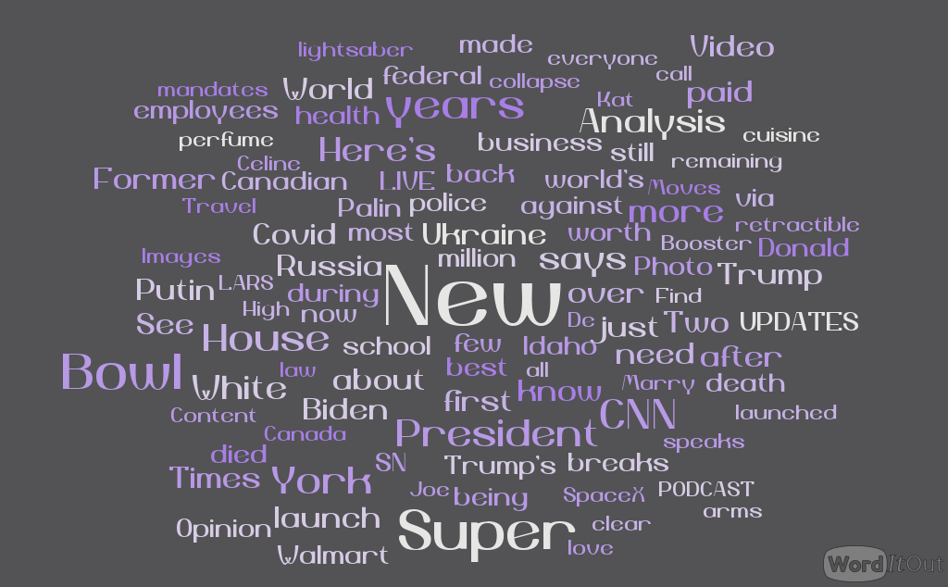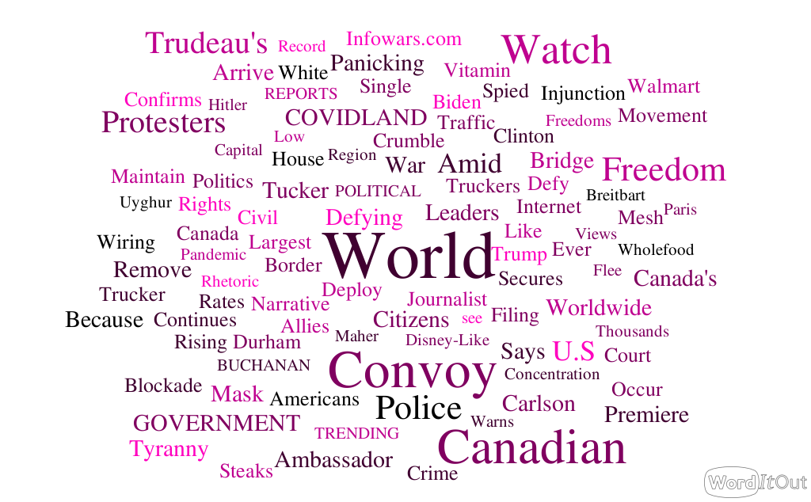

The Far-Right Watches Canada:

The Far-Right Looks to Canada:

The far-right in the United States is taking notice as trucker protests over COVID-19 restrictions enter day 6 of shutting down major roadways in Canadian cities, according to the front-page of InfoWars, the popular conservative news hub for mis-information.

An analysis of the home page for InfoWars, shown in the above left word cloud, indicates a sharp divide between the stories taking precedence at various news organizations, seemingly dependent on political leanings. For InfoWars, the Canadian protests dominate the news of the day, with “convoy” and “canadian” appearing 12 times across the landing page. In comparison, CNN’s home page, summarized in a word cloud in the top right image, indicates a much more varied and diverse set of stories, with few words standing out.

Certainly, the demonstrations in Canada, centered in Ontario, have caused major disruption for both the Canada and the United States. As the U.S. gears up for the Super Bowl Sunday evening, residents and organizers brace for similar demonstrations to pop up.

InfoWars frequently distributes anti-vaccination and anti-mandate propaganda to its base readership. With this nearly one-note focus on the Canadian convoy on its main page, it seems to signal a very real interest and desire within its readership to see similar resistance and demonstrations against COVID-19 public health measures.